**Circulatory/Respiratory Systems Workbook**

Teacher:

Student:

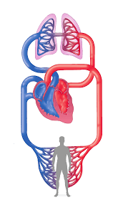

**Learning Intentions:**

* Identifying structures of the circulatory system
* Differences between Capillaries, Arteries and Veins
* Identifying the process of blood flow through the body
* Functions and components of blood
* Identifying structures of the respiratory system
* Understanding gas exchange in the lungs
* Understanding the mechanics of breathing

**Success Criteria:**

* Label the anatomy of the heart
  + Superior/Inferior Vena Cava, Pulmonary Valve, Tricuspid Valve, Right atrium/ventricle, Aorta, Pulmonary artery/vein, Left atrium/ventricle, aortic valve, pericardium,
* Explain the 5 functions of the circulatory system
  + Circulate blood, Transport nutrients, Transport waste, Maintain body temp, WBC’s
* Describe the flow of blood through the circulatory system
* Explain the function and components of blood
  + Plasma, RBC’s, WBC’s, Platelets
* Label the anatomy of the respiratory system
  + Air passages, Lungs, Diaphragm
* Explain the 5 functions of the respiratory system
  + Deliver oxygen, Gas exchange, Create speech, Smell, Expel heat
* Describe the process of gas exchange
* Explain what triggers the need to breathe
* Describe the mechanics of breathing
  + Inspiration, Expiration

Functional Anatomy

Circulatory system

Define each of the following terms.

* Blood Vessel ______________________________________________________________
* Arteries ______________________________________________________________
* Veins ______________________________________________________________
* Capillaries ______________________________________________________________
* Blood ______________________________________________________________
* Plasma ______________________________________________________________
* White blood cells ______________________________________________________________
* Red blood cells ______________________________________________________________
* Platelets ______________________________________________________________

The circulatory system (also known more commonly as the Cardiovascular System) consists of several structures that work together to transport oxygen and nutrients around the body.   
It consists of a network of arteries, veins, and capillaries, with the heart pumping blood through it. Its primary role is to provide essential nutrients, minerals, and hormones to various parts of the body. It’s also responsible for collecting metabolic waste from the cells and tissues to be expelled from the body.

There are 5 major functions of the circulatory system. In the space provided write a few brief sentences about each function.

* ________________________________________________________

___________________________________________________

* ________________________________________________________

___________________________________________________

* ________________________________________________________

___________________________________________________

* ________________________________________________________

___________________________________________________

* ________________________________________________________

___________________________________________________

The Heart

The heart is a muscular pump which contracts continuously to drive blood around the body through the blood vessels.

**Label the anatomy of the heart and the flow of blood.**

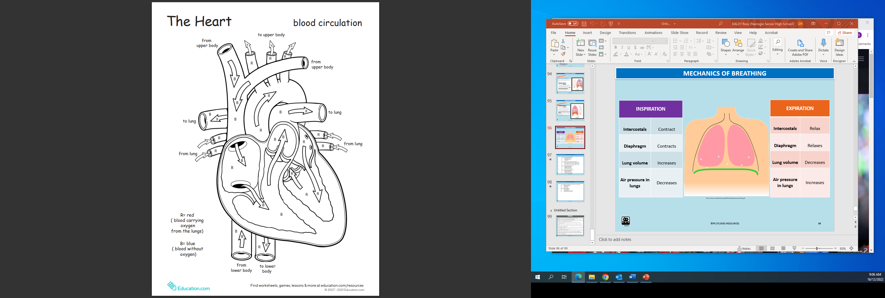

Functional Anatomy

Circulatory system

**Using the boxes explain the process of blood flow through the heart.**

Functional Anatomy

Circulatory system

Blood vessels are responsible for carrying blood from the heart, taking it to different parts of the body and then returning it to the heart.

**Complete the table below on the 3 types of blood vessels.**

|  |  |  |
| --- | --- | --- |
|  | **FUNCTION** | **STRUCTURE** |
| **ARTERIES** |  |  |
| **VEINS** |  |  |
| **CAPILLARIES** |  |  |

Blood

Blood is fluid that is transported through the pumping action of the heart via the blood vessels, to every cell of the body.

**List the 3 functions of blood. Label the components of blood, include percentages.**

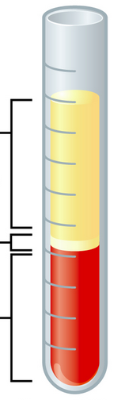

* _______________________________
* _______________________________
* _______________________________

Functional Anatomy

Respiratory system

List the function of each of the following essential respiratory system components.

* Nasal Cavity ______________________________________________________________
* Pharynx ______________________________________________________________
* Larynx ______________________________________________________________
* Trachea ______________________________________________________________
* Bronchi ______________________________________________________________
* Bronchioles ______________________________________________________________
* Alveoli ______________________________________________________________
* Lungs ______________________________________________________________

**Label the anatomy of respiratory system.**

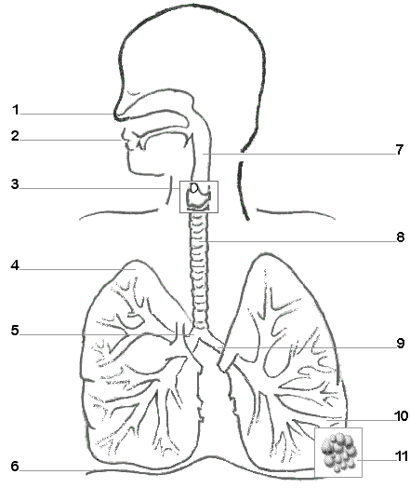

There are 5 major functions of the respiratory system. In the space provided write a few brief sentences about each function.

* ________________________________________________________

___________________________________________________

* ________________________________________________________

___________________________________________________

* ________________________________________________________

___________________________________________________

* ________________________________________________________

___________________________________________________

* ________________________________________________________

___________________________________________________

Describe the structures that an oxygen molecule passes through from the moment it enters the body at the mouth/nose until it leaves the heart to be delivered throughout the body. (HINT: there are 10 structures to list)

______________________________________________________________________________

______________________________________________________________________________

______________________________________________________________________________

______________________________________________________________________________

______________________________________________________________________________

______________________________________________________________________________

______________________________________________________________________________

______________________________________________________________________________

______________________________________________________________________________

______________________________________________________________________________

______________________________________________________________________________

______________________________________________________________________________

______________________________________________________________________________

______________________________________________________________________________

Functional Anatomy

Gas Exchange and Transport

In the lungs, gas exchange takes place in millions of tiny air sacs called alveoli. Oxygen diffuses from the alveoli through the capillary walls into the blood. Carbon dioxide diffuses in the opposite direction.

1. Label all the structures in the image
2. Use blue to colour the areas containing oxygen-poor blood
3. Use red to colour the areas containing oxygen-rich blood
4. 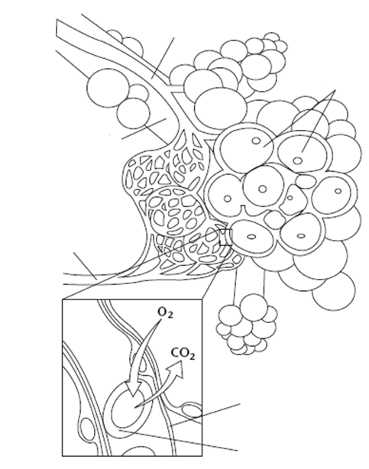Use grey to colour the areas which gas exchange takes place



Functional Anatomy

Gas Exchange and Transport – Exam Questions

Name the three features of the alveoli that are designed to increase the rate of gas exchange and explain how they achieve this.

______________________________________________________________________________

______________________________________________________________________________

______________________________________________________________________________

To help a gymnast overcome nerves before the start of her gymnastic routine her coach encourages her to do some diaphragmatic breathing and take a long slow exhale. Outline what the diaphragm is and explain how air is pushed out of the lungs through the process of expiration (exhalation). (5 marks)

______________________________________________________________________________

______________________________________________________________________________

______________________________________________________________________________

______________________________________________________________________________

______________________________________________________________________________

______________________________________________________________________________

______________________________________________________________________________

______________________________________________________________________________

Describe the mechanics of breathing, how the body breathes in (inspiration) and how the body breathes out (expiration). You may choose to include diagrams in your answer. (6 marks)

______________________________________________________________________________

______________________________________________________________________________

______________________________________________________________________________

______________________________________________________________________________

______________________________________________________________________________

______________________________________________________________________________

Functional Anatomy

Multi Choice questions

|  |  |
| --- | --- |
| 1. | Blood enters the heart from the inferior and superior vena cava into which chamber? |
| a. | Left atrium |
| b. | Right atrium |
| c. | Left ventricle |
| d. | Right ventricle |
|  |  |
| 2. | The major components of blood are: |
| a. | Plasma, red blood cells, white blood cells, platelets |
| b. | Enzymes, red blood cells, white blood cells, platelets |
| c. | Red blood cells, white blood cells, oxygen, venules |
| d. | White blood cells, oxygen, red blood cells, oxygen, plasma |
|  |  |
| 3. | What carries deoxygenated blood from the right side of the heart to the lungs? |
| a. | Pulmonary veins |
| b. | Pulmonary arteries |
| c.  d. | Aorta  Right Ventricle |
| 4. | What vessels allow oxygen and nutrients to pass into the cell and carbon dioxide and wastes to pass out? |
| a.  b.  c.  d. | Veins  Arteries  Ventricles  Capillaries |

Functional Anatomy

Short answer questions

**Question 1**

Describe three (3) differences between arteries and veins.

___________________________________________________________________

___________________________________________________________________

___________________________________________________________________

___________________________________________________________________

**Question 2**

Discuss the role blood plays in maintaining the body’s temperature constant. ___________________________________________________________________

___________________________________________________________________

___________________________________________________________________

___________________________________________________________________

**Question 3**

Describe the process of gaseous exchange.

___________________________________________________________________

___________________________________________________________________

___________________________________________________________________

___________________________________________________________________

**Question 4**

What role do alveoli play in the respiratory process.

___________________________________________________________________

___________________________________________________________________

___________________________________________________________________

___________________________________________________________________

**Question 5**

How do the intercostal muscles work together with the diaphragm to assist breathing? Briefly discuss the process of inhaling and exhaling and how these two muscle groups work together during these processes

___________________________________________________________________

___________________________________________________________________

___________________________________________________________________

___________________________________________________________________

___________________________________________________________________

___________________________________________________________________

___________________________________________________________________

**Question 6**

Describe the path of a molecule of air through the body into a cell and then follow a molecule of CO2 out of the body. Ensure that you describe all of the structures that the molecules travel through.

___________________________________________________________________

___________________________________________________________________

___________________________________________________________________

___________________________________________________________________

___________________________________________________________________

___________________________________________________________________

___________________________________________________________________

___________________________________________________________________

**Question 7**

Sketch a diagram of the heart showing the inside of it.

1. Label all the structures
2. Use arrows to show the movement of blood through the heart and the blood vessels
3. Label which regions are oxygenated and deoxygenated